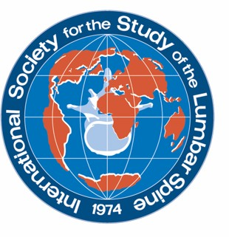
YOUNG INVESTIGATOR TRAVEL GRANT

Deadline for receipt of application form: 13 February 2026
Send application form to: issls2026@medicongress.com

Name:  (must be first author) | First name | Last name
 | E-mail | Country
Affiliation:
Title of submitted abstract
Please indicate that you: |  |  | Yes
Are the first author of the submitted abstract* (see note below)
Are a non-member of ISSLS
Have never attended an ISSLS meeting
Are a graduate student OR are four (4) years post-qualification OR are 40 years of age or younger if you are an independent researcher
Are planning to attend the ISSLS annual meeting in Milan

*Please note: if you are not the first author on the submitted abstract, you are NOT eligible for this award. Strictly no changes to authorship on the abstract can be made following submission of this application form.

